Let’s Recognise and Celebrate Volunteers!
2nd-8th June 2025
Our mission for Volunteers Week is to highlight the diverse volunteer community, showcase volunteering opportunities, and inspire positive change.
Volunteers are the backbone of UK communities, driving countless activities and initiatives. That’s why Volunteers’ Week is dedicated to honouring and recognising their hard work and invaluable contributions each year.
As you celebrate with your volunteers this year, take a moment to acknowledge every volunteer, past and present. From trustees to befrienders and fundraisers, this is the perfect time to reflect on their incredible impact.
Let’s come together to celebrate, appreciate, and inspire positive change in our communities!
Some Ideas of How to Celebrate:
Events can be a great way to bring people together during Volunteers’ Week. There are many ways you can celebrate volunteers in person or online or even inspire someone new to volunteer.
Recognition or Awards Evening
Hearing from those they've helped and receiving formal recognition can mean a lot to volunteers. Hosting a recognition or awards evening is a great way to celebrate their contributions and show appreciation.
A Celebration Coffee Morning
Hosting a Coffee Morning, provides a casual, informal way to show appreciation for your volunteers. It’s a great opportunity to connect, chat, and thank them for their valuable contributions. Its also a great way to encourage new people to come along and become volunteers.
Recruitment Fair or Open Day
Volunteers’ Week is a great time to attract new volunteers, showcase efforts, and promote your organisation. Hosting a recruitment fair or an open day can help promote and engage potential volunteers.
Host a Big Lunch
The Big Lunch weekend takes place this year on 7–8 June, making it a fantastic opportunity to celebrate the amazing volunteers who make a difference in our communities and help make your area a better place.

Tips for Engaging and Recruiting Volunteers
If you are planning to recruit volunteers or want to refresh your volunteer engagement process, these tips are a good place to start. Having clear processes and offering an enjoyable experience for volunteers will help you build a strong and committed volunteer team.
1.Planning is Key Planning for volunteering is important to ensure that both your organisation and your volunteers have a positive experience. Think about: Why are you involving volunteers? What role will volunteers play in your group? What policies and processes do you need to have in place to ensure you are prepared for involving volunteers?
2.Describing your volunteer roles. Scout volunteer teams work together with a clear purpose, shared tasks, and flexible volunteering opportunities, making it more accessible and enjoyable for everyone. Volunteers are part of a team, with a team description outlining purpose, outcomes, and tasks. Teams decide how to allocate tasks, tailoring them to individual skills, interests, and availability. This helps potential volunteers understand what is expected of them and whether the role is a good fit. Try to include: What tasks the volunteer could be doing; Where and when they could be needed, and how often; Any training or support you will provide; What benefits will the volunteers gain, e.g. skills, references etc.
3.Offer Flexible and Micro-Volunteering Opportunities Not everyone can commit to regular, long-term volunteering. Offering flexible or micro volunteering opportunities, such as one-off tasks, remote volunteering, or short-term volunteering, allows more people to get involved. This flexibility can appeal to people with busy schedules or those who are looking to try volunteering for the first time.
4.Create a clear and simple process for getting involved. Make it as easy as possible for people to express interest in volunteering. Ensure your group has: Clear information about the roles available; A simple sign-up process or expression of interest form; Information about what happens next after they sign up
5. People are more likely to volunteer if they can see the positive difference they could make. Share the impact your volunteers have through: Stories, photos, or videos of volunteer work in action; Statistics or key achievements made possible by volunteers; Testimonials from beneficiaries who have benefited from volunteer support; Demonstrating the value of volunteering helps inspire others to get involved and shows appreciation for your existing volunteers.
6. Your current volunteers can be some of your best advocates when it comes to engaging new volunteers. Encourage them to: Invite friends, family, or colleagues to get involved; Share their volunteering experiences on social media; Participate in volunteer recruitment events or open days Hearing first-hand about someone’s positive volunteering experience can often inspire others to get involved.
7. Promote Volunteer Stories. Sharing real-life volunteer stories is a powerful way to inspire others to get involved. Ask current volunteers if they are happy to share their experiences, either in writing or through short videos. These stories can highlight the positive impact of volunteering and help potential volunteers understand what they can expect from getting involved.
8. Recognise and celebrate your volunteers. Taking the time to thank and recognise your volunteers is essential for keeping them engaged and motivated. You can do this by: Sending personalised thank-you messages; Hosting small appreciation events or celebrations; Sharing volunteer success stories publicly; Presenting certificates or length of service awards. Feeling valued and appreciated encourages volunteers to continue their involvement and recommend volunteering to others.
For more information on how to recruit volunteers, check out the Scout website: https://www.scouts.org.uk/volunteers/growing-scouts/

Volunteer in West Lancashire
Volunteering is a vital component of UK society, with millions contributing their time and skills annually across the UK. These inspiring statistics highlight the incredible contributions of volunteers and the potential for even greater engagement across the UK.
Volunteering added £4.6 billion in productivity gains to the UK economy in 2024
14.2 million people in the UK have formally volunteered at least once a month

Volunteers are the backbone of UK communities, driving countless activities and initiatives.
25 million people in the UK volunteered informally at least once in the year

Volunteers are the backbone of UK communities, driving countless activities and initiatives. Check out our website for more information:
https://www.scouts.org.uk/volunteer/
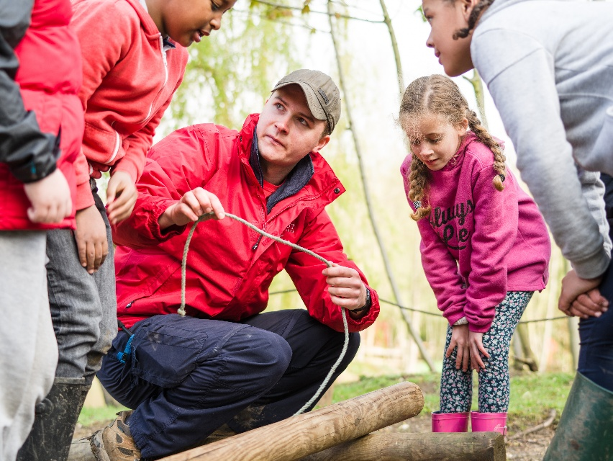
“Being a trustee for West Lancs Scouts is a unique opportunity to help shape the future—supporting the movement that gives young people the skills for life. It’s incredibly rewarding to know that, behind the scenes, you’re helping create opportunities for adventure, confidence, and growth in every young person we reach.”

